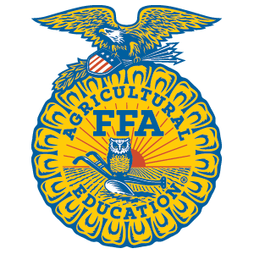
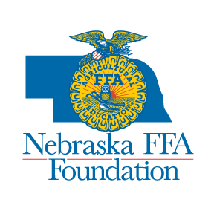
Gary Scharf Helping Hand Award

In Honor of Gary Scharf for his Commitment and Service
to Nebraska FFA and Agricultural Education
Presented by the Nebraska FFA Foundation

Established in 2009, this award recognizes a Nebraska agriculture instructor/FFA advisor for what he/she has done in “helping others,” specifically in the school and community, outside of
agricultural education and FFA. The recipient of this award is one who exemplifies the commitment, self-sacrifice, and genuine kindness that defined Gary Scharf’s life.

Information about the Award:

- One Nebraska agriculture instructor/FFA advisor will be recognized annually with a plaque and $500 cash award.
- Anyone can make the nomination – students, fellow teachers, school officials, parents and/or others in the community.
- The recipient will be announced and recognized at the Thursday evening session, during the Nebraska State FFA Convention.
- Submit only one completed application for nominee. Supplemental pages can be attached, but only as supporting letters for the original application form.

All Applications Must Be Postmarked by
March 1, 2016

Applications should be returned to:
Nebraska FFA Foundation
PO Box 94942
Lincoln, NE 68509-4942

Application Submitted by: ___________________________________________________________
Name

__________________________________________________________________________________
Profession/Relationship to Nominee (Student, Teacher, Businessperson, etc.)

Telephone #: ____________________________________E-mail:____________________________

Name of Agriculture Instructor/FFA Advisor Being Nominated:

__________________________________________________________________________________

School and/or Chapter: _____________________________________________________________

Please answer the following questions about your applicant.

- Please name two characteristics/attributes that describe the person you are nominating with a brief explanation of how these qualities apply to this nominee.

1.

2.

- In two or three sentences, please describe what sets this individual apart as someone who goes “above and beyond?”

- Please provide up to three specific examples of what he/she has done in the school and/or community, above what is expected and done as the agriculture instructor/FFA Advisor?

- Why does this teacher/advisor deserve to receive the Gary Scharf Helping Hand Award?

